FULL ADDER

EXP.NO: 23

AIM:

To design and implement the full adder using Logisim
simulator.

PROCEDURE:

1) Pick and place the necessary gates.

2) Insert 3 inputs into the canvas.

3) Connect the inputs to the XOR gate, AND
gate and OR gate.

4) Insert 2 outputs into the canvas.

5) Make the connections using the connecting
wires.

6) Verify the truth table.

TRUTH TABLE:

Sum=(A
⊕
B) ⊕
Cin

Carry=A.B
+ (A ⊕
B)

OUTPUT
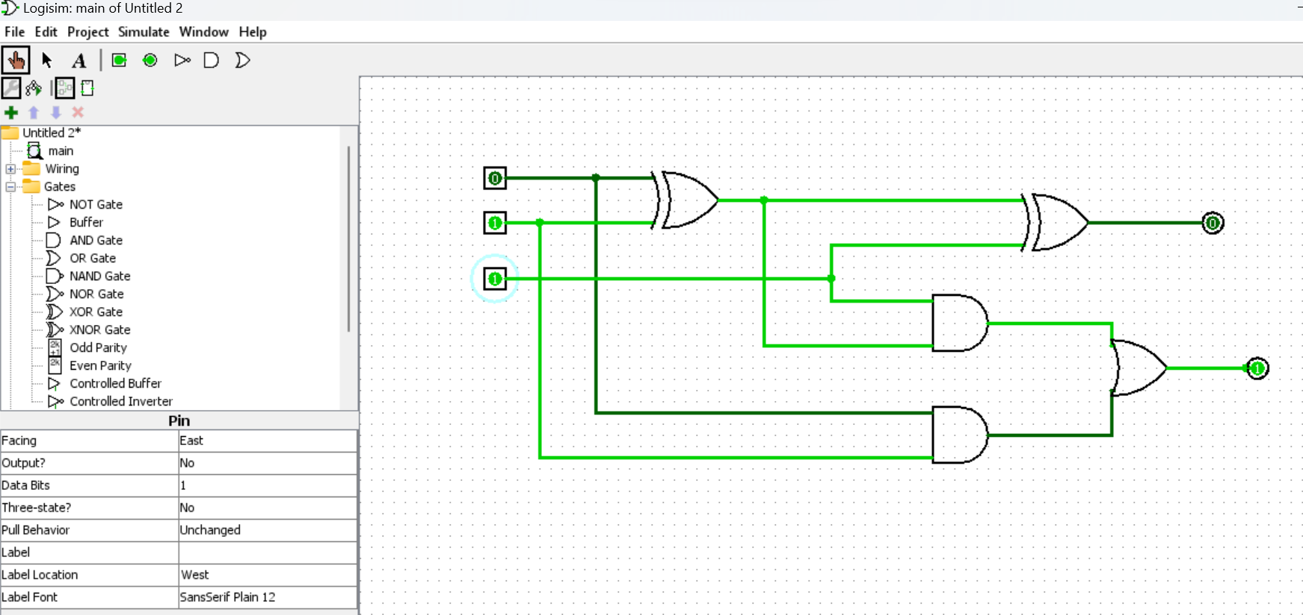

RESULT: Thus full adder has been designed and
implemented successfully using logisim simulator.

